SECTION A
Question 1
Look at the picture. Rearrange the words to form correct sentences. (10 marks)
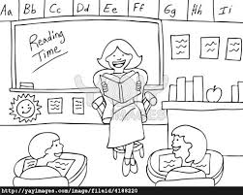

- is Puan Jeni. This
___________________________________________

- Teacher. is she
___________________________________________

- English teaches She in two year.

___________________________________________

- dress. She wear likes to

___________________________________________

- kind is She beautiful. And

SECTION B
QUESTION 2
Look at the pictures. Name the clothing. ( 8 MARKS)
gloves
jacket
skirt
boots

- 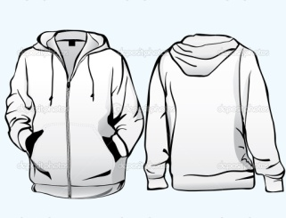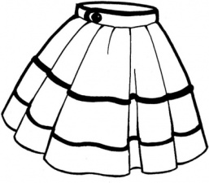 2.

- 4.


QUESTION 3
Arrange the words in alphabetical order. (12 MARKS)
trowel
bicycle
photograph
wheelbarrow

scissors
duck
hoe
ant

skirt
rake
coat
milk

1. _________________ 7. ________________
2. _________________ 8. _________________
3. _________________ 9. _________________
4. _________________ 11. _________________
5. _________________ 12. _________________
6. _______________

QUESTION 4
Read the text. Then fill in the blanks with words given. (10 MARKS)
This is my pet. I call it Jungkoi. It is a chubby cat. It has black and white fur. I give it milk and whiskas everyday. Jungkoi loves to purr and play with any round objects. It sleeps on the sofa. I love my cat very much.

Jungkoi
pet
black
whiskas
sofa
chubby
fur
round
purr
love

This is my ______________. I call it ____________. It is a
_________ cat. It has __________ and white ______________.
I give it milk and _____________every day. Jungkoi loves to
___________ and play with any ____________ objects. It sleeps
on the ___________. I _____________my cat very much.

QUESTION 5
Transfer non-linear presentation to another non-linear presentation.
Read about the three things below and complete the blanks correctly.(10MARKS)

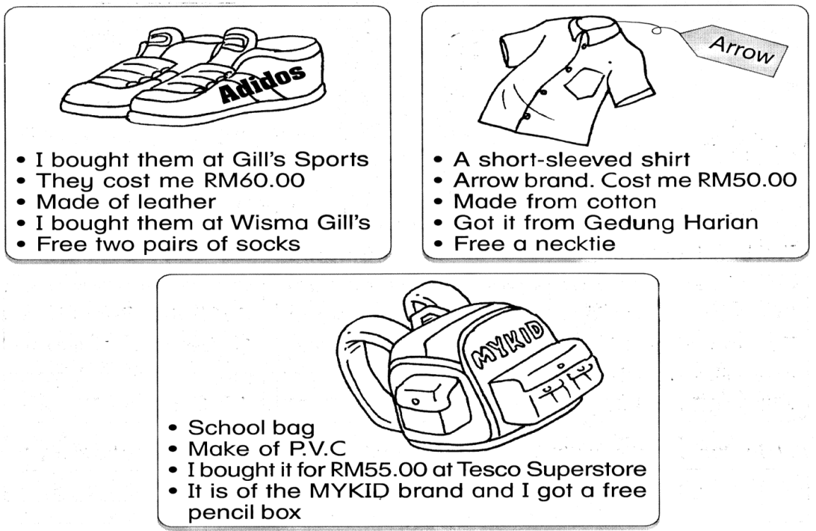
Item | Brand | Cost | Made of | Bought at | Free gift
Shoes | Adidos |  |  | Gill’s Sports
Shirt |  | RM 50.00 |  |  | necktie
Bag |  |  | P.V.C

SECTION C
Question 6
Use all the words given to write good sentences about the picture. ( 10 marks)

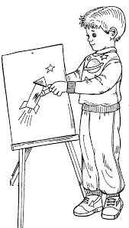

- Adam . - This

________________________________________________________

- years old. - He - eight

________________________________________________________

- In - year - two Anggerik

________________________________________________________
- goes - to - Sk Batu

________________________________________________________

- likes - drawing

_______________________________________________________________________

