NO. KAD PENGENALAN / NO. SIJIL LAHIR

ANGKA GILIRAN

UJIAN PENCAPAIAN SEKOLAH RENDAH 2016 ( AR 1 )
DAERAH JULAU
BAHASA INGGERIS ( PENULISAN ) 014
Mac 2016
1 Jam 15 minit
JANGAN BUKA KERTAS SOALAN INI SEHINGGA DIBERITAHU
1. Tulis nombor kad pengenalan atau nombor sijil kelahiran
Untuk kegunaan pemeriksa

Bahagian | Markah Penuh | Markah Diperolehi
A | 10
B | i) 3
B | ii) 12
C | 25
JUMLAH | 50

dan angka giliran kamu pada petak yang disediakan.
2. Kertas soalan ini mengandungi tiga bahagian, iaitu
Bahagian A, Bahagian B dan Bahagian C.
3. Kamu hendaklah menjawab ketiga-tiga bahagian.
4. Bagi Bahagian C, kamu boleh memilih sama ada
menjawab Soalan 1 atau Soalan 2.
5. Jawapan kamu hendaklah ditulis pada ruang yang
disediakan dalam kertas soalan ini. Sekiranya ruang
yang disediakan tidak mencukupi, sila dapatkan helaian
tambahan daripada pengawas peperiksaan. Helaian
tambahan (jika ada) hendaklah diikat dan
dihantar bersama-sama kertas soalan.

KERTAS SOALAN INI MENGANDUNGI 8 HALAMAN BERCETAK

Section A
[10 marks]

Study the notes below and use the information to complete the text.
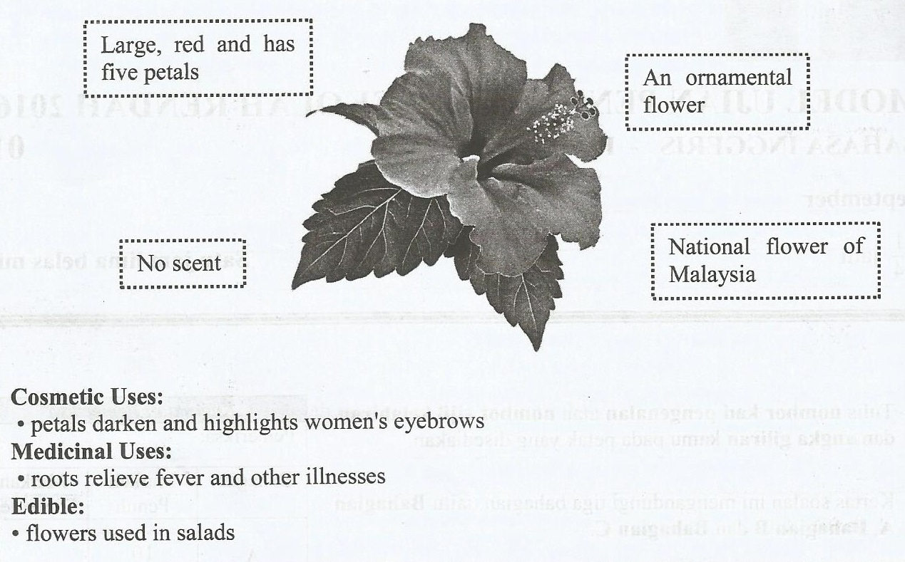
Teliti nota-nota di bawah dan gunakan maklumat yang diberi untuk melengkapkan teks.

Based on the notes, complete the text below with the correct information.
Berdasarkan nota-nota, lengkapkan teks di bawah dengan maklumat yang betul.

The hibiscus is the national flower of Malaysia. The hibiscus is large, red and has five

_____________________ . The flower has no ____________________ . The flower grows
( 1 ) ( 2 )
abundantly in Malaysia. It is grown as an ___________________. The hibiscus has many
( 3 )
uses. The petals are used as cosmetics to darken and highlight ____________________. Its
( 4 )
roots’ are used to relieve fever and other illnesses. The hibiscus flower is used for hair care. The

flowers too can be eaten and are used ___________________.
( 5 ) (10 marks)
SECTION B
[15 marks]

( i) Study the poster about an anniversary celebration of a shopping complex and answer the
following question in the spaces provided.
Teliti risalah di bawah tentang sambutan ulang tahun sebuah pusat membeli belah dan
jawab soalan berikutnya di ruang yang disediakan.
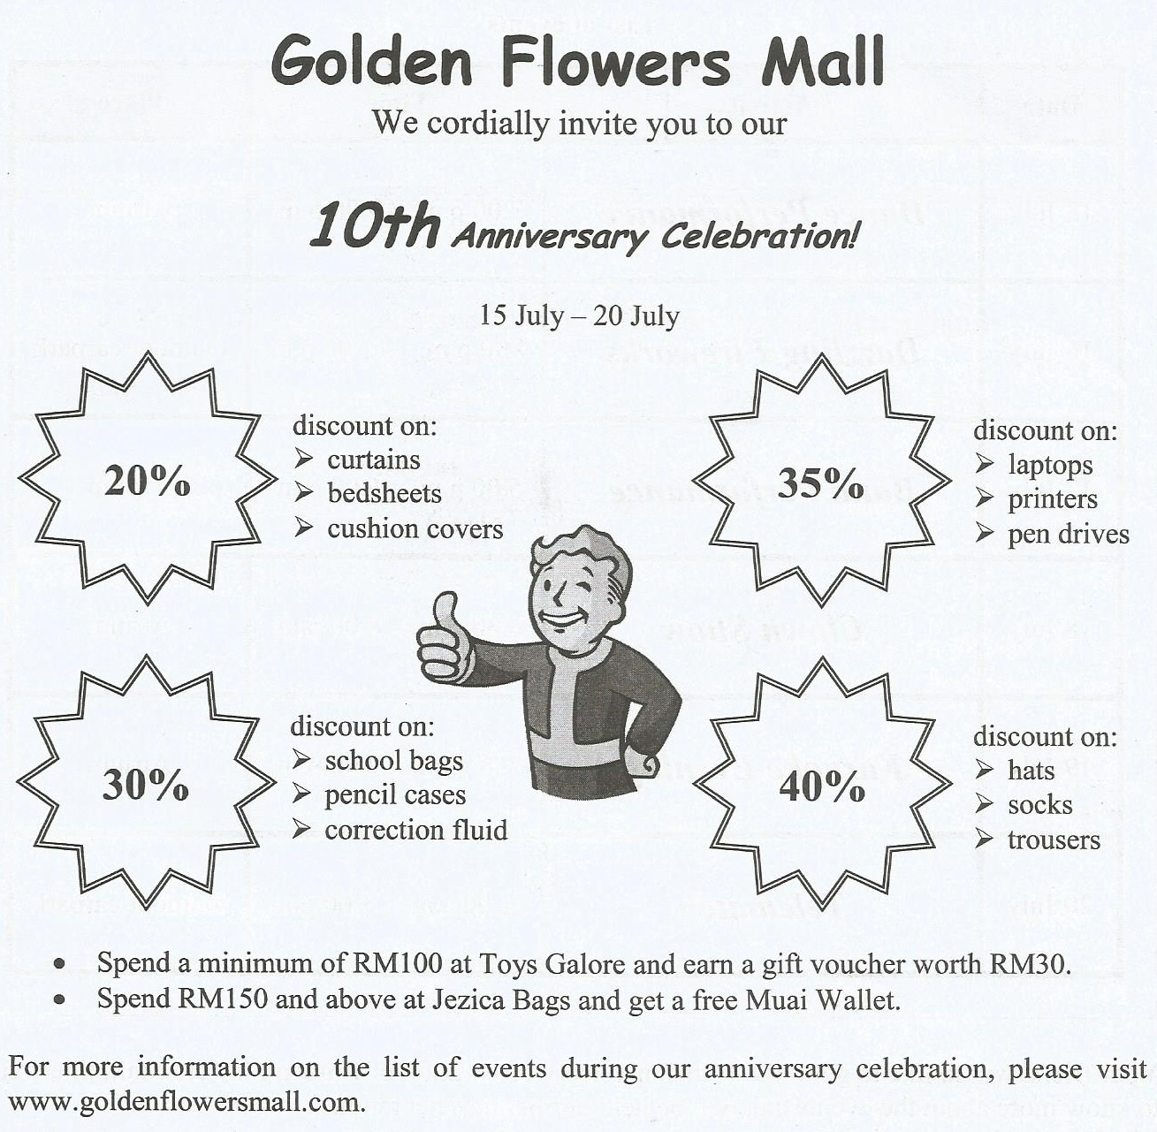

List three items that are sold at a discount at Golden Flowers Mall.

i. __________________________________________________
ii. __________________________________________________
iii. __________________________________________________
[3 marks]

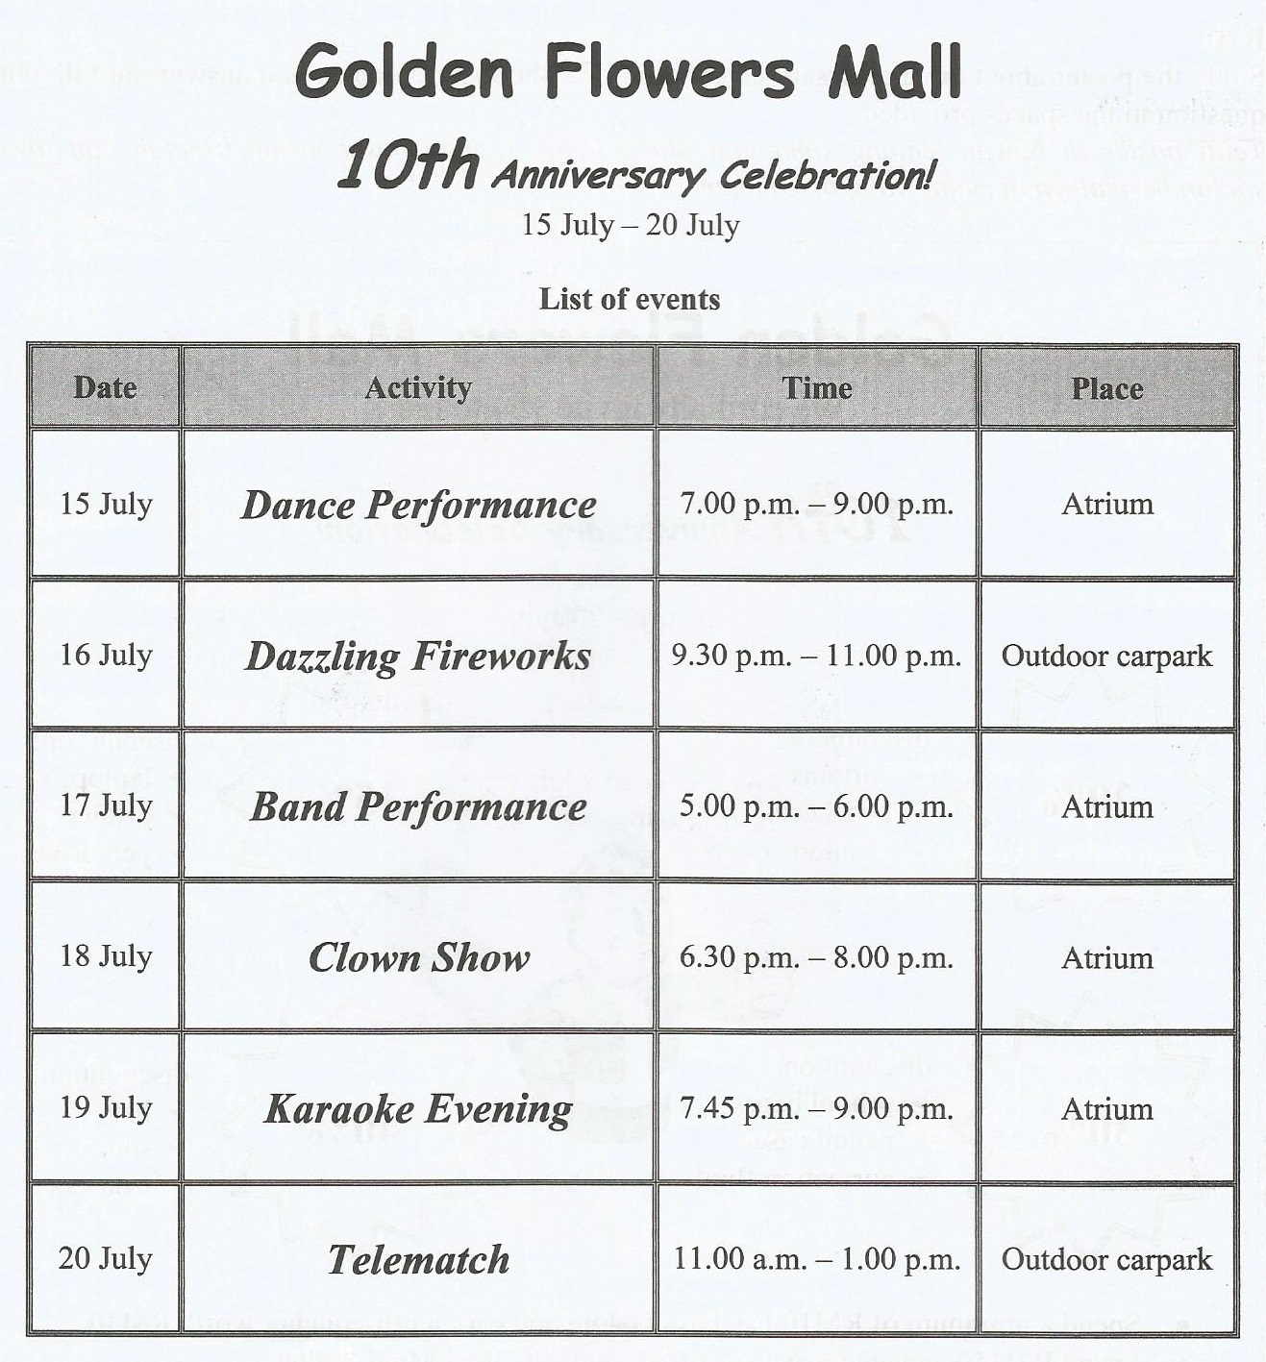
( ii )

Your friend would like to go to the 10th anniversary celebration of Golden Flowers Mall. She wants to know more about the events that will be held during the celebration.

Write an email to your friend to tell her about at least three events that she can attend.
Write your answer between 50 to 80 words.
From : | Date : 10 July 2016
To : | Time : 8.30 p. m.
Subject : 10th Anniversary Celebration of Golden Flowers Mall
__________________________________________________________________________________________________________________________________________________________________________________________________________________________________________________________________________________________________________________________________________________________________________________________________________________________________________________________________________________________________________________________________________________________________________________________________________________________________________________________________________________________________________________________________________________________________________________________________________________________________________________________________________________________________________________________________________________________________________________________________________________________________________________________________________________________________________________________________________________________________________________________________________________________________________________________________________________________________________________________________________________________________________________________________________________________________________________________________________________________________________________

( 12 marks )
Section C
[25 marks]

This section consists of two questions. Answer one question only.
Bahagian ini mengandungi dua soalan. Jawab satu soalan sahaja.

Question 1
Write a story based on the picture below. You may use the words given to help you. Write your answer in the space provided. Write your story between 80 to 100 words.
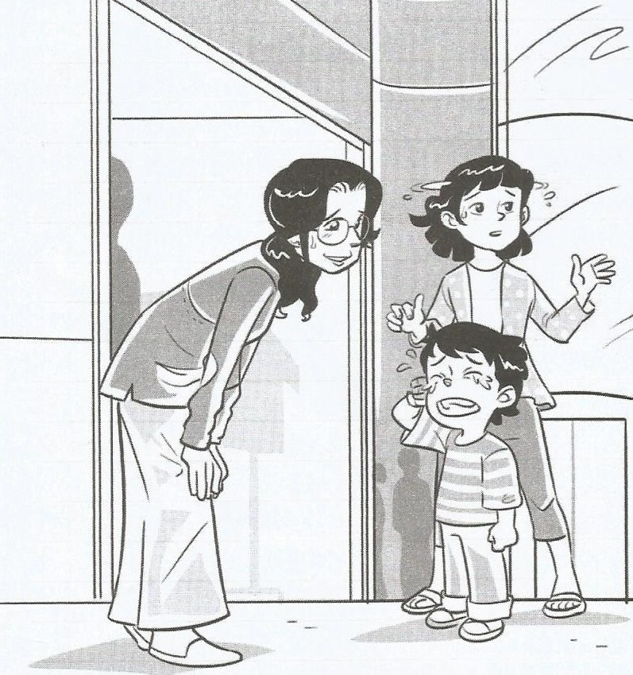 | restaurant boy crying  mother lost thanked  reunited glad  information counter
Begin your story with :
Mary and her sister, Tina went to the shopping centre to watch movie. After the movie……….
OR
Question 2
Write a story based on the pictures below. You may use the words given to help you. Write your answer in the space provided. Write your story between 80 to 100 words.
Tulis sebuah cerita berdasarkan gambar-gambar di bawah. Kamu boleh menggunakan perkataan-perkataan yang diberikan untuk membantu kamu. Tulis jawapan kamu di ruang yang disediakan. Panjangnya jawapan kamu hendaklah antara 80 hingga 100 patah perkataan.

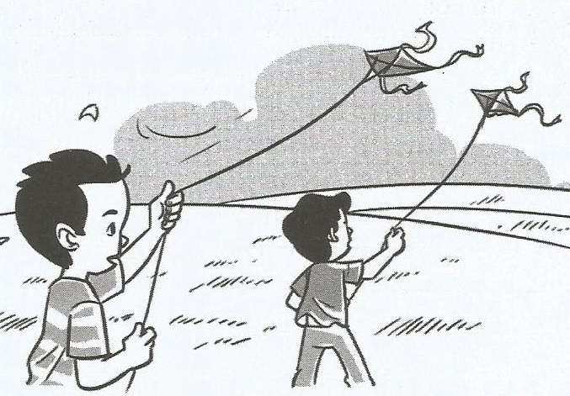  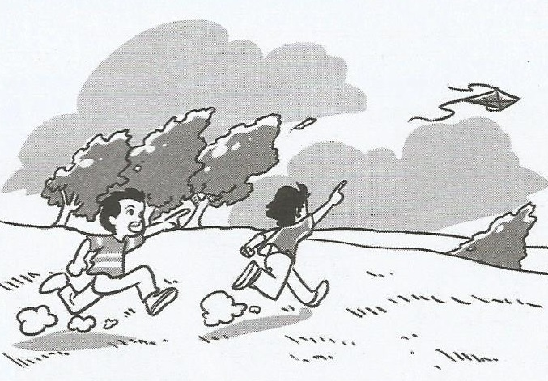 | - field - fly - kites - wind - blew
 | - string - snapped - ran after - reach
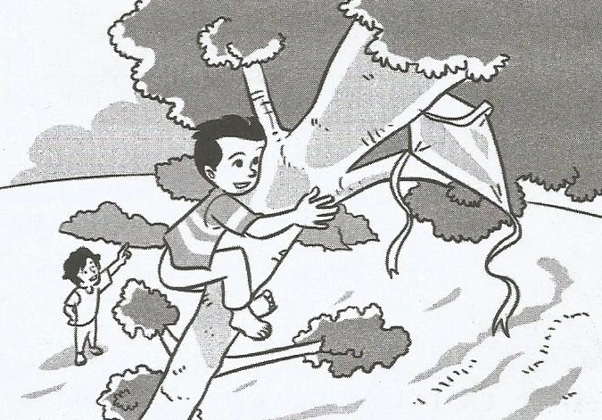 | - caught - branch - tree - glad
_________________________________________________________________________________________________________________________________________________________________________________________________________________________________________________________________________________________________________________________________________________________________________________________________________________________________________________________________________________________________________________________________________________________________________________________________________________________________________________________________________________________________________________________________________________________________________________________________________________________________________________________________________________________________________________________________________________________________________________________________________________________________________________________________________________________________________________________________________________________________________________________________________________________________________________________________________________________________________________________________________________________________________________________________________________________________________________________________________________________________________________________________________________________________________________________________________________________________________________________________________________________________________________________________________________________________________________________________________________________________________________________________________________________________________________________________________________________________________________________________________________________________________________________________________________________________________________________________________________________________________________________________________________________________________________________________________________________________________________________________________________________________________________________________________________________________________________________________________________________________________________________________________________________________________________________________________________________________________________________________________________________________________________________________________________________________________________
KERTAS SOALAN TAMAT

