SULIT

UJIAN PRA UPSR 1

DAERAH JULAU

BAHASA INGGERIS – PEMAHAMAN

BAHAGIAN A 013

1 hour 15 minutes Satu jam lima belas minit

________________________________________________________________________________________

JANGAN BUKA KERTAS SOALAN INI SEHINGGA DIBERITAHU

1. Kertas soalan ini mengandungi dua bahagian : Bahagian A dan Bahagian B.

2. Kamu dikehendaki menjawab semua soalan dalam kedua-dua bahagian ini.

3. Tiap-tiap soalan dalam Bahagian A diikuti oleh empat pilihan jawapan iaitu
A, B, C dan D. Bagi setiap soalan, pilih satu jawapan sahaja. Hitamkan jawapan kamu
pada kertas jawapan objektif yang disediakan. Jika kamu hendak menukar jawapan,
padamkan tanda yang telah dibuat. Kemudian hitamkan jawapan yang baharu.

4. Ceraikan Bahagian B daripada kertas soalan ini.

__________________________________________________________________________________
Kertas soalan ini mengandungi 4 halaman bercetak di Bahagian A
dan 7 halaman bercetak di Bahagian B.

013 1 SULIT
SULIT 013
Section A
[20 marks]

Choose the best answer to complete the sentence.
Pilih jawapan yang terbaik untuk melengkapkan ayat berikut.

1 The lioness and its cubs _____________ walking to the river now.
A is
B are
C was
D were

2 Jenny has done her homework, ____________ she?
A has
B have
C had
D hasn’t

3 Mr. Ramesh ______________ a movie last night.
A watch
B watches
C watched
D watching

4 Siew Leng leaned ____________ the wall.
A against
B below
C along
D over

5 There was not _____________ water in the kettle when I looked at it just now.
A little
B some
C many
D much

Choose the most suitable proverb.
Pilih peribahasa yang paling sesuai.

6 Family relationship is more important than relationships with other people. As the
saying goes, ______________________ .
A charity begins at home
B home is where the heart is
C blood is thicker than water
D birds of a feather flock together

013 2 SULIT
SULIT 013

Choose the best answer for each blank.
Pilih jawapan terbaik untuk setiap tempat kosong.

Faris and his friends _______(7)_______ playing football in the field. Suddenly, Faris stumbles

over a stone ______(8)______ falls down. He hurts his left knee and it is bleeding. Faris walks

home______(9)______. His mother cleans the cut on his knee and applies some

ointment on it.

7 A is
B are
C was
D were

8 A or
B so
C and
D but

9 A joyfully
B slowly
C happily
D sleepily

Choose the word that has the similar meaning as the underlined word.
Pilih perkataan yang sama erti dengan perkataan yang bergaris.

10 The stream flows swiftly down the hill.

A dangerously
B naturally
C rapidly
D slowly

Choose the sentence with the correct punctuation.
Pilih ayat yang mempunyai tanda baca yang betul.

11 A Lee Ings’ grandmother will visit New Zealand next June.
B Lee ing’s grandmother will visit New Zealand next June.
C Lee Ing’s grandmother will visit new Zealand next June.
D Lee Ing’s grandmother will visit New Zealand next June.

013 3 SULIT
SULIT 013

Look at the picture and choose the best answer.
Lihat gambar dan pilih jawapan yang terbaik.
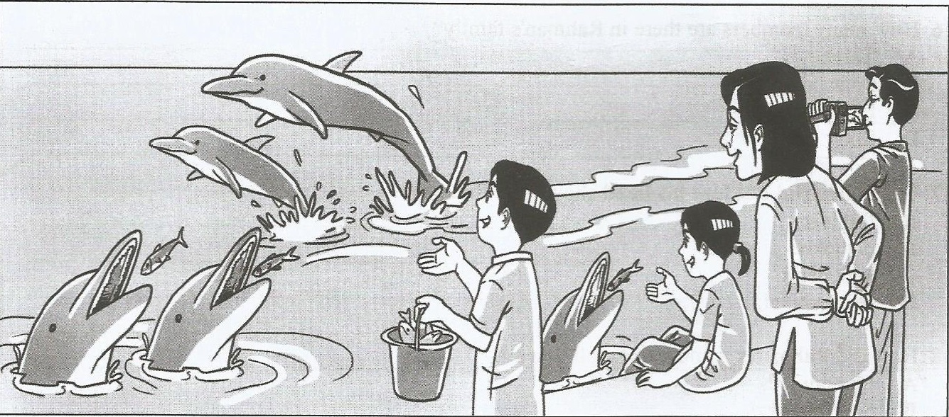

My family and I spent several days at an island resort during the last school holiday. The

resort organized many nature-based activities for ______(12)_______ visitors. One of the most

exciting activities _______(13)_______ feeding a pod of bottlenose dolphins, which visit the

resort every evening. During our visit, we saw ______(14)_______ dolphin calf. It was a male

______(15)______ cheeky calf . We had a wonderful time at the resort.

12 A it
B its
C it’s
D itself

13 A were
B are
C is
D was

14 A a
B an
C the
D -

15 A because
B and
C but
D so
013 4 SULIT
SULIT 013
Questions 16 to 20
Read the passage below carefully and answer the questions that follow.
Baca petikan di bawah dan jawab soalan-soalan yang berikutnya.

My classmate and I went on a trip to the funfair last Saturday. Our teachers, Puan Zaharah and Mrs. Liew accompanied us there. We boarded the bus at 9.00 a.m. and arrived at the funfair half an hour later. Before the bus driver drove off, he informed us that he would return to fetch us at 4.00 p.m.
After that, Puan Zaharah bought tickets for everyone. Mrs. Liew divided us into two groups. The pupils in Puan Zaharah’s group would go to the games booths, while those in Mrs. Liew’s group would go to the rides. We promised to meet near the ticket booth at 12.30 p.m. so we could have lunch together.
I was in Mrs. Liew’s group. I could not wait to explore the funfair and I tried out all the rides. They were thrilling and exciting. Everyone was screaming one minute and laughing the next when we rode on the roller coaster. After that, we went on the merry-go-round, ferris wheel and tea cups. Soon it was 12.25 p.m. so Mrs. Liew quickly led us to the ticket booth.

16 When did the writer and his classmates arrive at the funfair?
A 7.30 a.m.
B 8.30 a.m.
C 9.30 a.m.
D 10.30 a.m.

17 What did Puan Zaharah do once they got off the bus?
A Bought tickets for everyone.
B Divided the pupils into groups.
C Took one group to the games booth.
D Discussed the pickup time with the driver.

18 The word explore shows that the pupils _______________ .
A walked and looked around
B travelled about for some time
C investigated their surroundings
D searched for the most interesting activity

19 Mrs Liew led her group to the ticket booth so they could _______________ .
A go home early
B buy more tickets
C wait for the bus to come
D have lunch with the others

20 From the passage, we know that the pupils probably had lunch ________________.
A at a fast food restaurant
B without their teachers
C near the ticket booth
D at different times

NO KAD PENGENALAN/
NO. SIJIL KELAHIRAN

ANGKA GILIRAN

UJIAN AR 1
UJIAN PENCAPAIAN SEKOLAH RENDAH, 2016
DAERAH JULAU

BAHASA INGGERIS – PEMAHAMAN 013
Bahagian B
________________________________________________________________________________________
Untuk Kegunaan Pemeriksa
JANGAN BUKA KERTAS SOALAN INI SEHINGGA
Kod Pemeriksa :
DI BERITAHU
Markah
No. Soalan
1. Tulis nombor kad pengenalan atau nombor sijil

21
(a)
kelahiran dan angka giliran kamu pada petak-
(b)
petak yang disediakan.
(c)

2. Jawapan kamu hendaklah ditulis pada ruang
(a)

22
yang disediakan dalam kertas soalan.
(b)

3. Serahkan Bahagian B ini bersama-sama borang
(c)
jawapan objektif kepada pengawas
(d)
peperiksaan pada akhir peperiksaan
(e)

23
(a)
(b)

(c)
(d)
(e)

24
(a)
(b)

25
(a)

(b)
(c)
Jumlah

30

________________________________________________________________________________________

Kertas soalan ini mengandungi 7 halaman bercetak.

013 5 SULIT
SULIT 013

Section B
[30 marks]
Question 21
Based on the given pictures, give the correct answers in full sentences.
Write your answers in the spaces provided.
Berdasarkan gambar-gambar, berikan jawapan dalam ayat yang penuh.
Tulis jawapan di tempat yang disediakan.

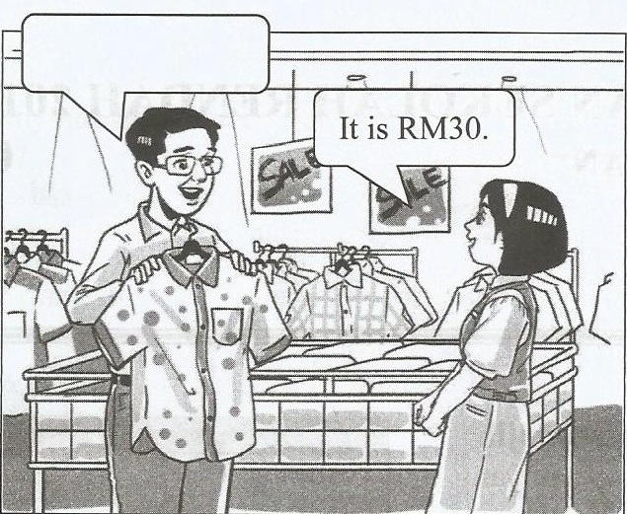
(a)
Answer :

_____________________________________

_____________________________________

_____________________________________
[2 marks]

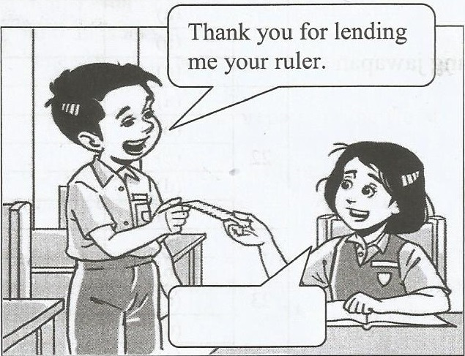
(b) Answer :

_____________________________________

_____________________________________

_____________________________________
[2 marks]

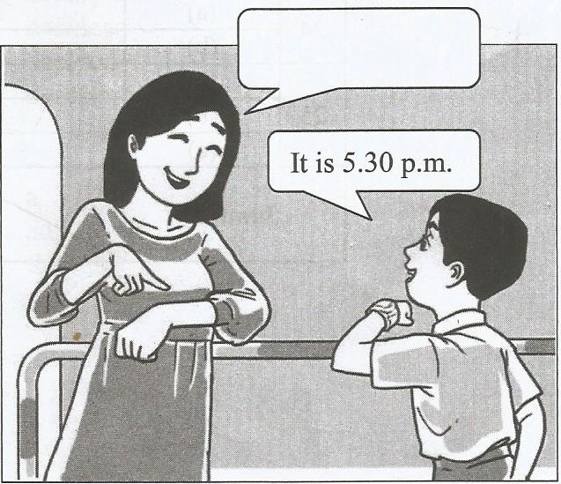
(c)
Answer :

_____________________________________

_____________________________________

_____________________________________
[2 marks]

013 6 SULIT
SULIT 013

Read the story below and answer the questions that follow.
Baca cerita di bawah dan jawab soalan-soalan berikutnya.

Once upon a time, there lived a king who liked to play tricks on his people. Though playful, the king was always worried about the safety of his country. So, he ordered his soldiers to build a big drum. After a few weeks, the drum was completed. It was as big as an elephant.

The king then called all his people and said, “I have a very big drum. When the country is in the danger, I will beat the drum. When you hear the drum, come to my palace quickly. You must all help keep the country safe”.

One evening, the king was bored. So, he decided to play a trick on his people. He beat the drum loudly. All the people ran quickly to the palace to see what was happening. “It is all right,” said the king. “I was only playing a trick on you. Everything is safe. You can all go home.”

A few months later, some enemies came to the palace. They wanted to rule the country. The king was afraid and beat the big drum loudly. When the people heard the drum, they just laughed. Nobody came to help the king.

Question 22
Tick (√) the correct answer.
Tanda (√) bagi jawapan yang betul.

(a) The king wanted a big drum to ……………..

play tricks on his people.

look as big as elephant.

warn the people of danger.

[1 mark]
(b) The king called his people to …………….

beat the big drum.

show off his big drum.

tell them about his plan.

[1 mark]

013 7 SULIT
SULIT 013

Write your answers in the spaces provided.
Tulis jawapan anda dalam ruangan yang diberi.

(c) Why do you think the people laughed when the king beat the drum?

__________________________________________________________________________________

__________________________________________________________________________________

__________________________________________________________________________________
[2 marks]

(d) In your opinion, what probably happened to the king at the end of the story?

___________________________________________________________________________________

___________________________________________________________________________________

___________________________________________________________________________________
[2 marks]

(e) The king played a trick on his people. Was the action correct? Why?

___________________________________________________________________________________

___________________________________________________________________________________

___________________________________________________________________________________
[2 marks]

013 8 SULIT
SULIT 013

Read the flyer below and answer the questions that follow.
Baca risalah di bawah dan jawab soalan-soalan yang berikutnya.
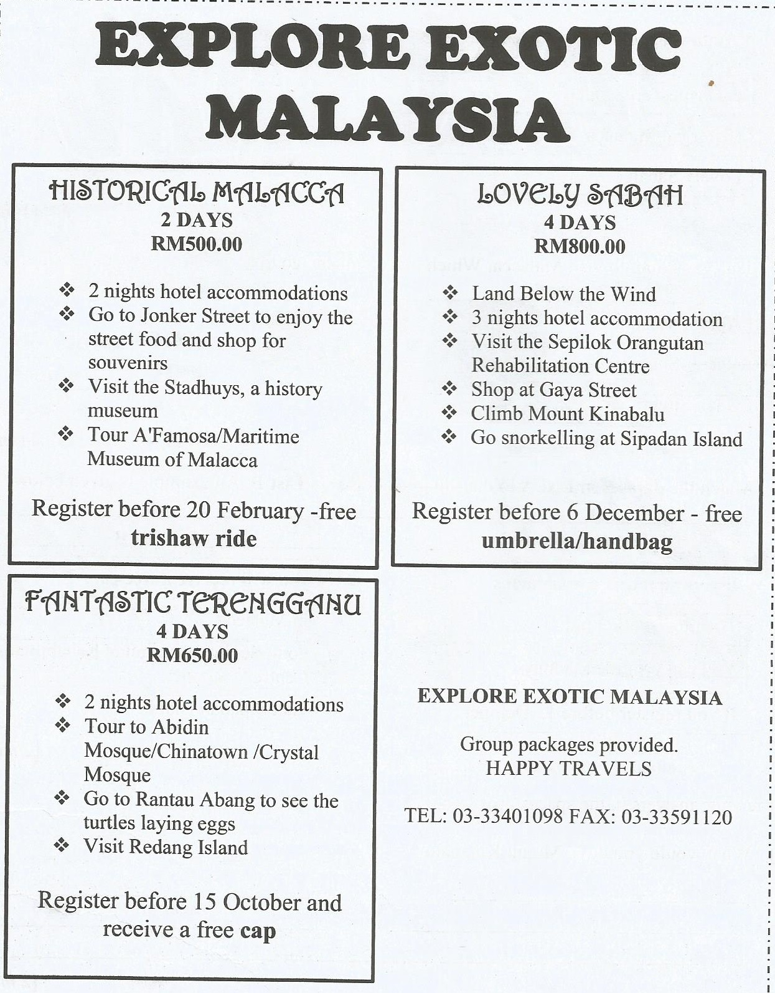

Question 23
Tick (√) the correct answer.
Tandakan (√) bagi jawapan yang betul.

(a) If Anita wanted to see turtles laying eggs, she would choose the package ………

Fantastic Terengganu
Historical Malacca
Lovely Sabah
[1 mark]

013 9 SULIT
SULIT 013

(b) Janice is going to visit Malacca. Which place will she go to?

Abidin Mosque
Jonker Street
Gaya Street
[1 mark]

(c) Match the phrases in List A to the suitable phrases in List B. An example is given below.

List A |  | List B
If you want to see orangutans |  | you will receive a free cap.
To enjoy snorkeling, |  | in Malacca.
You can visit the Stadhuys |  | go to Sepilok Orangutan Rehabilitation Centre.
If you register before 15 October |  | visit Sipadan Island.

[2 marks]

Write your answers in the space provided.
Tulis jawapan anda dalam ruangan yang diberi.

(d) What would you do at Mount Kinabalu?

____________________________________________________________________________________

____________________________________________________________________________________

____________________________________________________________________________________

[2 marks]

(e) What do you understand by the phrase ‘3 nights hotel accomodation’?

_____________________________________________________________________________________

_____________________________________________________________________________________

_____________________________________________________________________________________

[2 marks]

013 10 SULIT SULIT 013

Study the poster and read the dialogue below. Answer the questions that follow.
Teliti risalah dan baca dialog di bawah. Jawab soalan-soalan berikutnya.

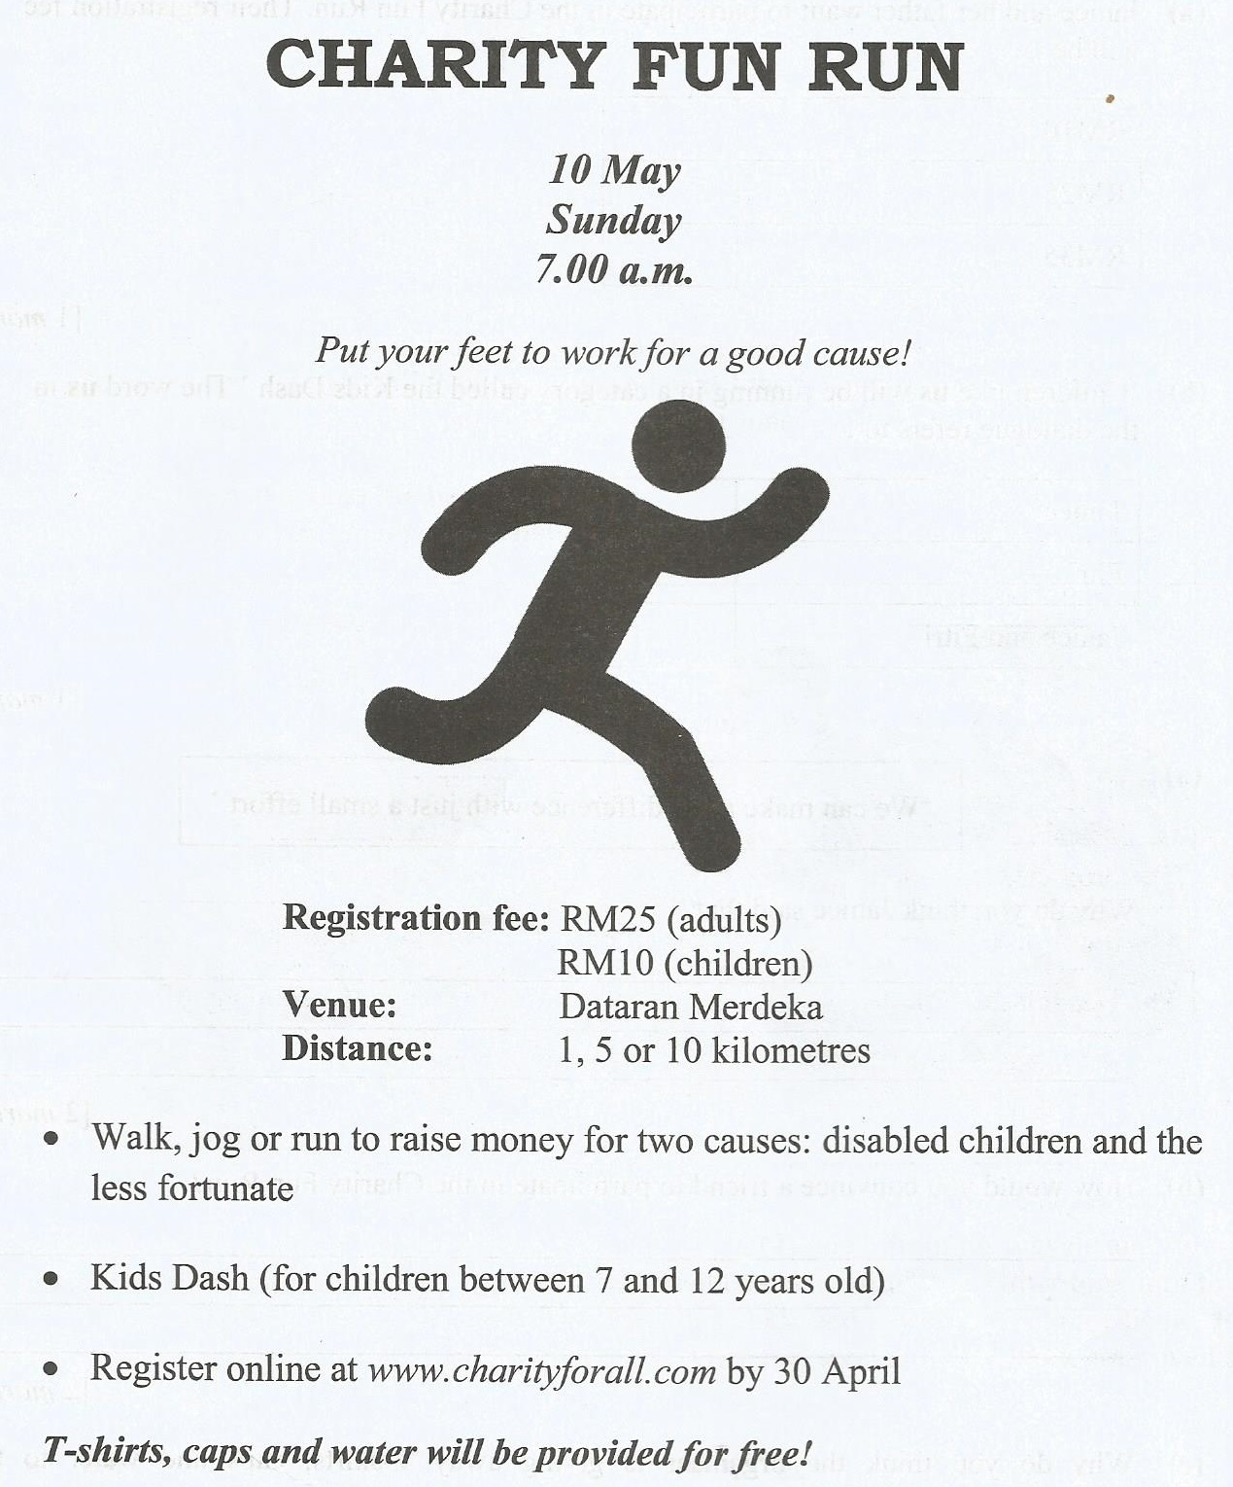

Janice : Fitri, let’s participate in the Charity Fun Run. It will be held this coming Sunday?
Fitri : That sounds interesting! Sure, I’ll join you.
Janice : Children like us will be running in a category called the Kids Dash.
Fitri : I’ve an idea! Let’s get our friends to participate too.
Janice : That’s good idea. We can make a big difference with just a small effort.

013 11 SULIT SULIT 013

Questions 24 and 25
Tick (√) the correct answer.
Tandakan (√) bagi jawapan yang betul.

24 (a) Janice and her father want to participate in the Charity Fun Run. Their registration
fee will be ……….

RM 10
RM 25
RM 35
[1 mark]
(b) ‘Children like us will be running in a category called the Kids Dash.’ The word us in the
dialogue refers to ……….

Janice
Fitri
Janice and Fitri
[1 mark]

“ We can make a big difference with just a small effort.”
25 (a)

Why do you think Janice said that?
________________________________________________________________________________

________________________________________________________________________________

________________________________________________________________________________
[2 marks]

(b) How would you convince a friend to participate in the Charity Fun Run?
________________________________________________________________________________

________________________________________________________________________________

________________________________________________________________________________
[2 marks]

(c) Why do you think the organizer is giving away T-shirts, caps and water to the
participants? Give reasons to support your answer.
________________________________________________________________________________

________________________________________________________________________________

________________________________________________________________________________
[2 marks]
KERTAS SOALAN TAMAT

