SECTION A
QUESTIONS 1-4
Choose the best words to fill in the blanks.
1. February is the ___________ month of the year.
A first
B one
C third
D second
2. I have made a mistake. Please lend me your ________.
A ruler
B pencil
C eraser
D crayon
3. Her mother baked a chocolate _________.
A egg
B cake
C ice cream
D bowl

4. My father uses a __________ to gather the leaves.
A rake
B gloves
C Wheelbarrow
D watering can 1.
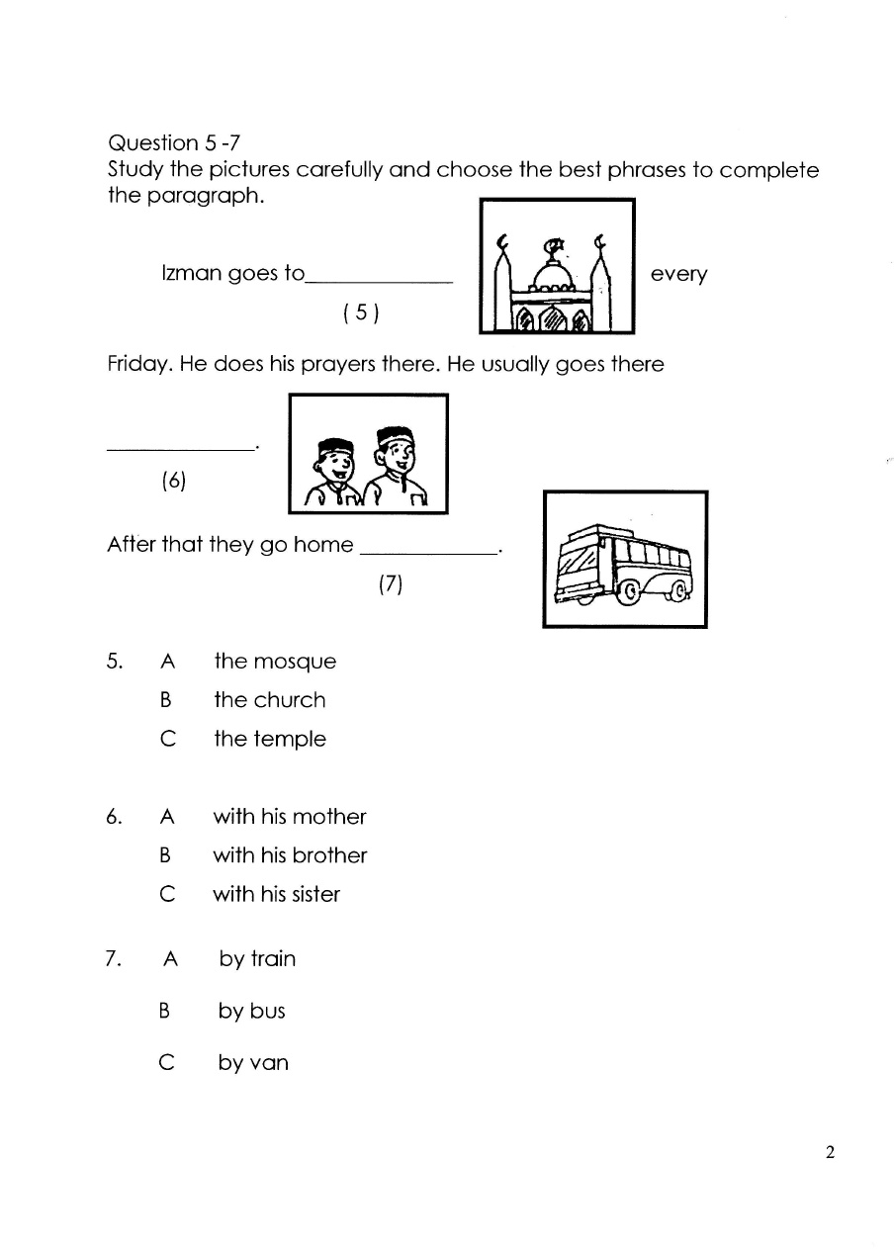
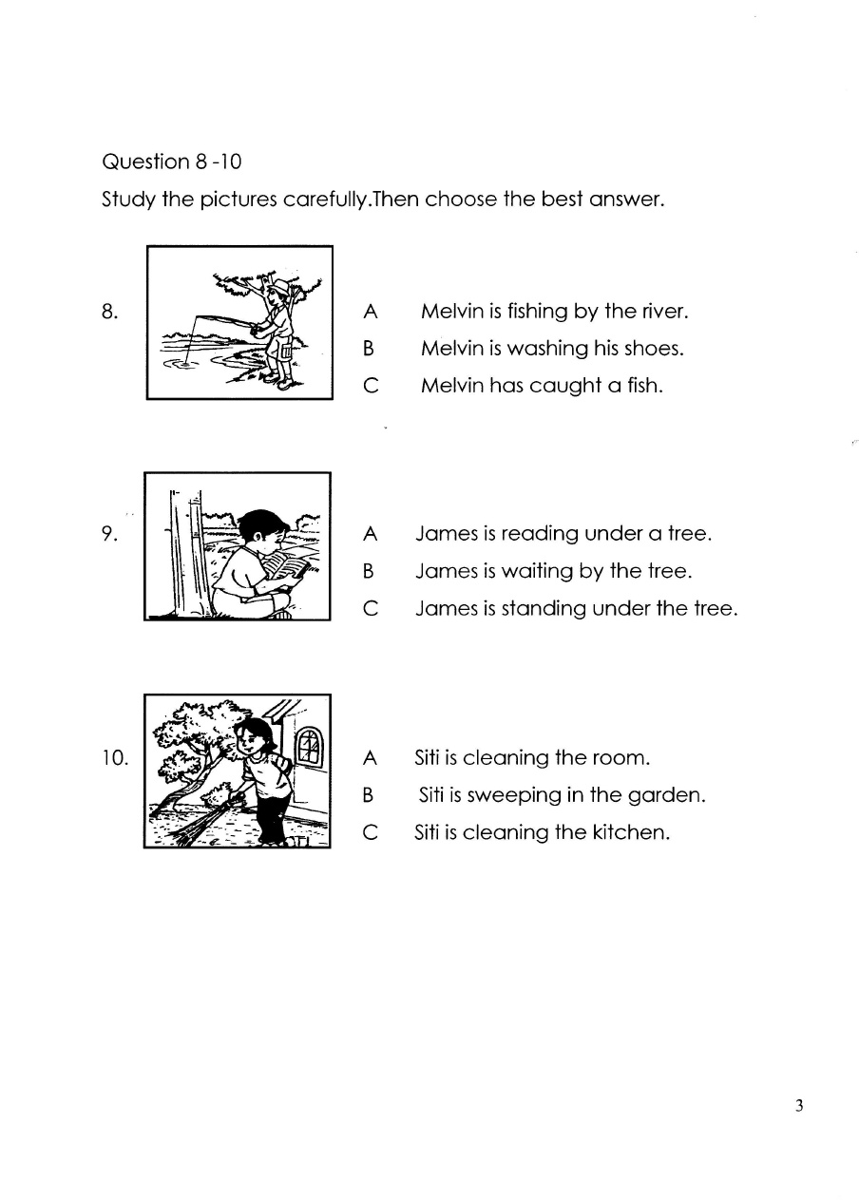
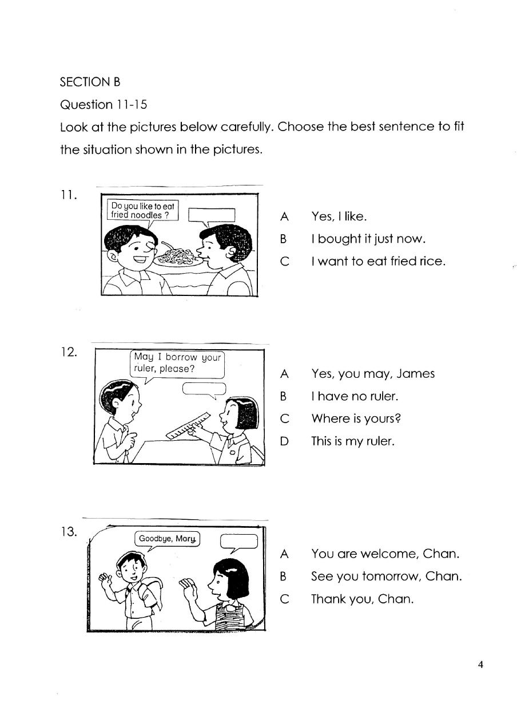
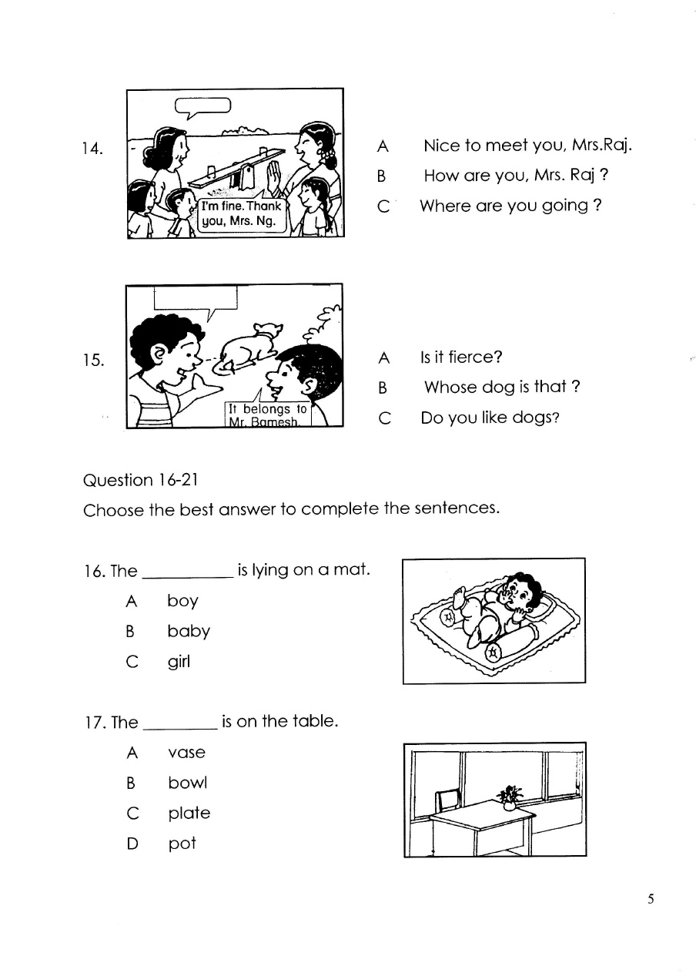


18. The ball is in the __________.
A box
B basket
C cupboard

19. Put the book _______ the table.

A in
B on
C under

20. Amir ______ Malek are good friends.
A and
B so
C or

21. Alvin, Raju and Osman are playing football. ________ are in the field.
A You
B She
C They

6
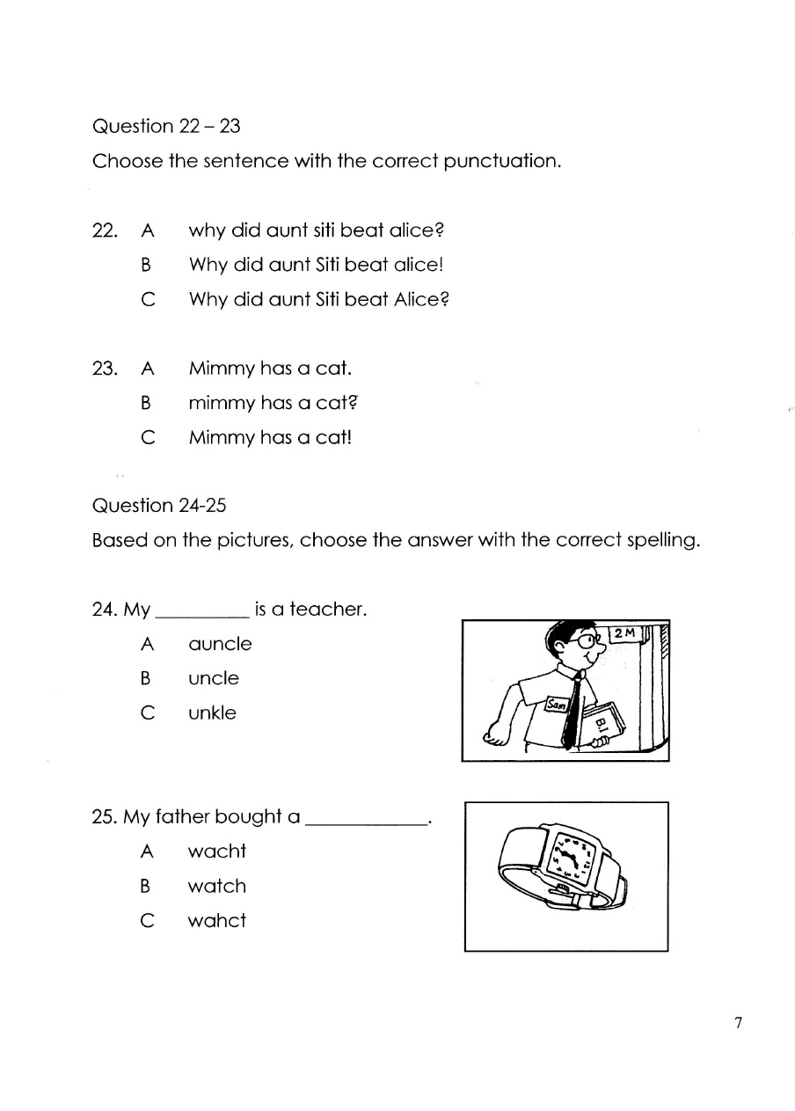
QUESTIONS 26-30
Based on the picture, Choose the correct spelling.
26.
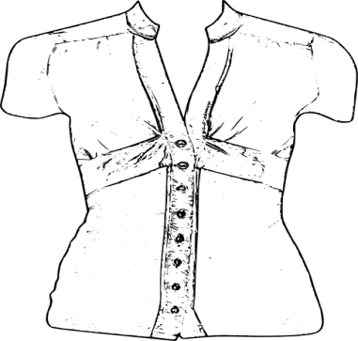

A bloues
B blouse
C bluseo
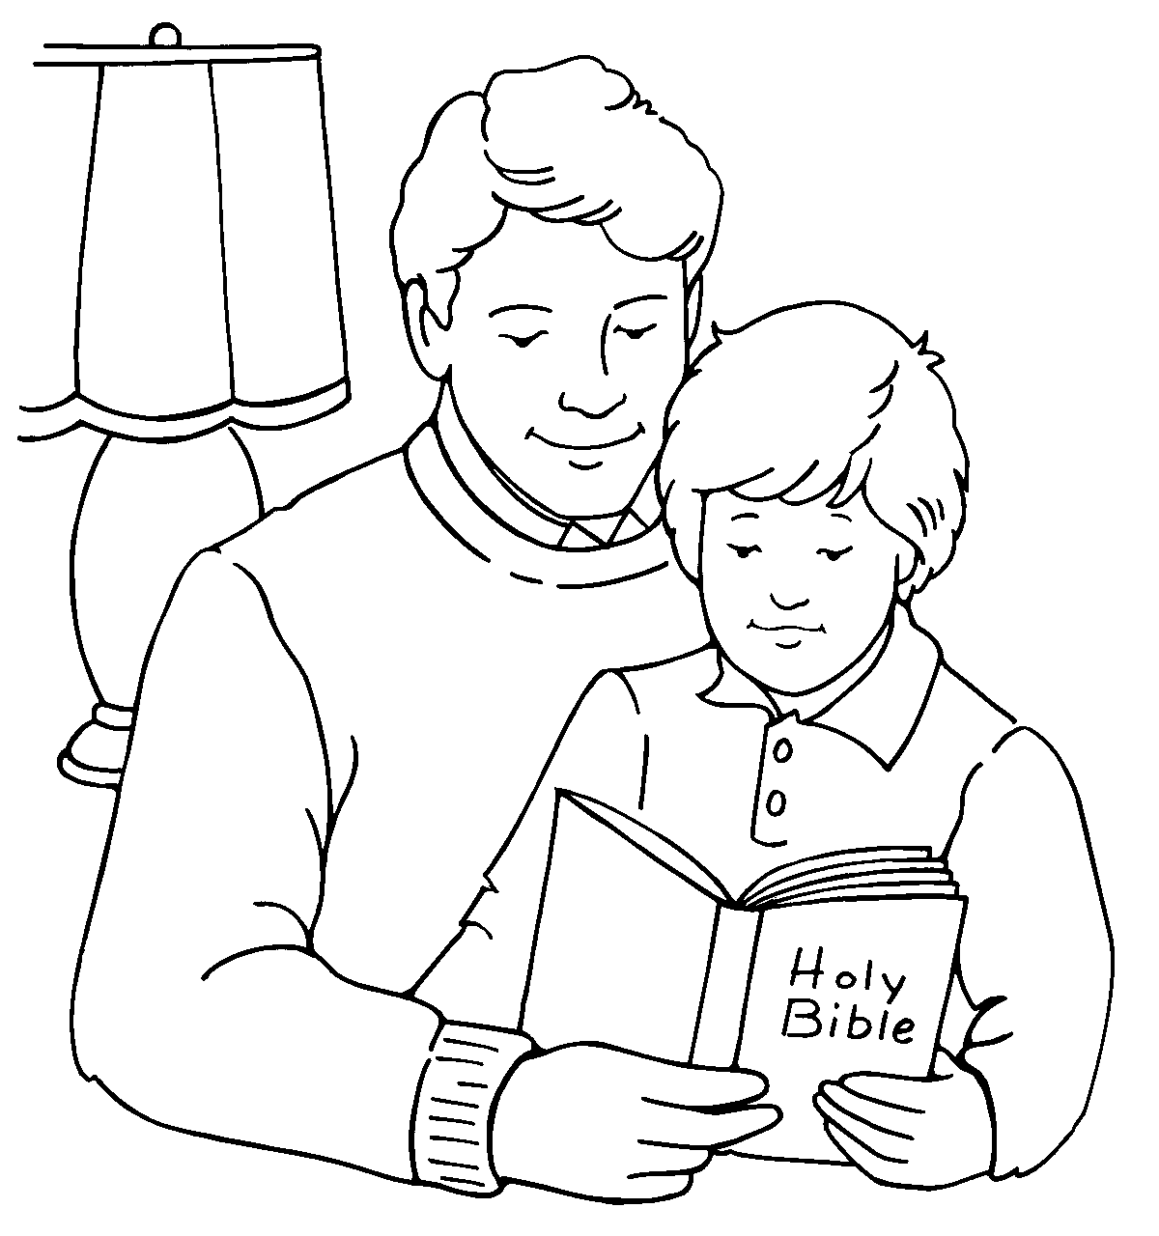27.

A raeding
B reading
C radeing

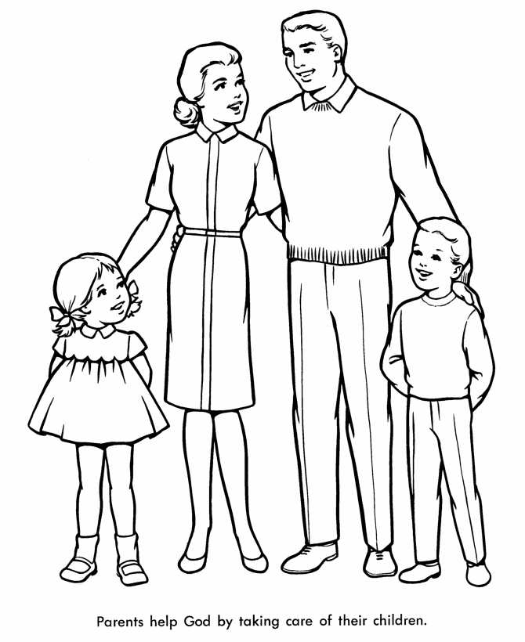28.

A famliy
B fmaily
C family
29.

A nuser
B nurse
C nusre
30.
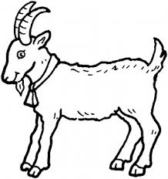

A gaot
B goat
C gooat

SECTION D
QUESTIONS 31-35
Choose the correct phrases.
31.

A singing
B dancing
C cycling

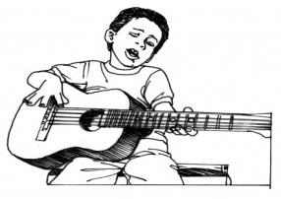32.

A collecting stamps
B listening to music
C playing guitar

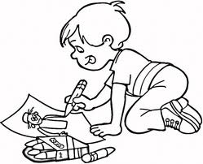 33.

A fishing
B reading
C drawing

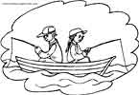34.

A cycling
B fishing
C swimming

SECTION E
QUESTIONS 35-40
Look at the picture and read the passage carefully. Based on the picture and the passage, choose the best answer to fill in the blanks.
Last week, Ali and his family went for a picnic. They went to Damai Beach. They went there by car. They left their home very early in the morning. It took them about two hours to reach their destination. When they arrived, Ali and his brother ran to the sea to swim. After swimming for three hours, Ali and his family had lunch which was prepared by his mother. Ali felt tired but very happy that day.

Circle the correct answers.

35. What did Ali do last week?
Ali and his family ………
A at the park
B at the home
C went for a picnic

36. Where did they go?
A They went to Damai Beach.
B They went to school.
C They are at the garden.

37. When did they go there?
A They left their home very early in the morning.
B They went out very late.
C They left their home by bus.

38. How did they go there?
A They went there by car.
B They went there by bas.
C They left their home very early in the morning.

39. Where did Ali swim?
A He swim in the pond.
B He swim in the lake.
C Ali and his brother ran to the sea to swim.

40. How did Ali feel that day?
A angry
B happy
C sad

9

